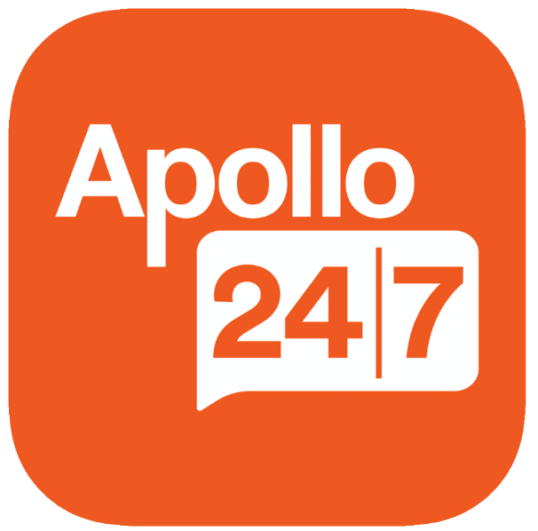

Product Dissection for Apollo 24|7

Overview

Apollo 24/7 is India’s largest omnichannel digital healthcare platform that holds the core belief, “Expertise is for Everyone”. It was launched on 5th February 2020 as a digital healthcare platform of the Apollo brand and group of hospitals. It combines Apollo’s legacy of clinical excellence, affordable cost, and forward-looking research with cutting-edge technology to make the best quality healthcare easily accessible to every Indian, online. It enables millions of Indians to avail an entire gamut of services, including online doctor consultations, online pharmacy services, and diagnostic tests from the comfort of their homes, while also providing chronic condition management, along with a digital vault where one can upload all their medical history.

Product Dissection and Real-World Problems Solved by Apollo 24/7
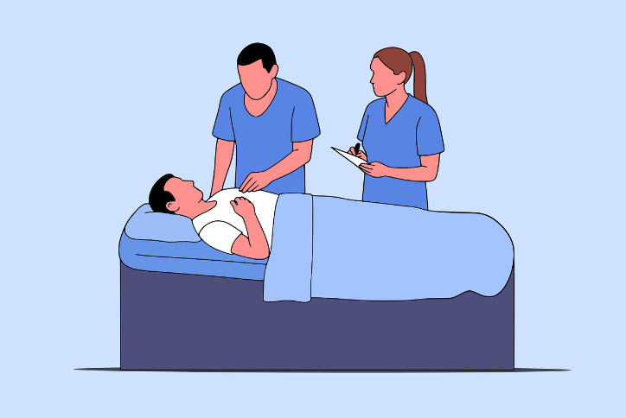
Being India’s largest digital healthcare platform, Apollo 24/7 has effectively addressed multiple real-world problems through innovation and introduction of services that Indians had not previously experienced. Healthcare being the primary focus, Apollo 24/7 introduced online doctor consultations, which allowed any Indian with a smartphone, across the country, to be able to book consultations with some of the best healthcare providers in India with just a few taps and sometimes within minutes. The consultations can be in the form of video, telephonic, or online chat based, and experience was made seamless with users being able to upload relevant documents pertaining to medical history even before the consult is initiated. With the recent introduction of the ‘On-Time Guarantee’ feature, individuals can filter through healthcare providers to make sure there is no delay in addressing of concerning health problems.

The platform, through its ‘online pharmacy’ feature, allows individuals to order medications that can be either delivered directly to their doorstep or to be picked up at the nearest Apollo pharmacy. It is one of the few online medical stores that guarantees quality and authenticity of medications along with a 2-hour delivery guarantee of all medications on a prescription in over 10,000 pin codes across India. Not only does the pharmacy include medications, but it also includes healthcare essentials such as supplements, health devices, Ayurvedic products, among many more.

It offers a service by which multiple diagnostic tests can be booked to be performed from the comfort of one’s home and includes home sample collection, same-day delivery of reports for many tests and affordable pricing. For tests that require hospital visits, they can be booked from the comfort of home and results can be delivered electronically without having to go back to the hospital to collect the results.
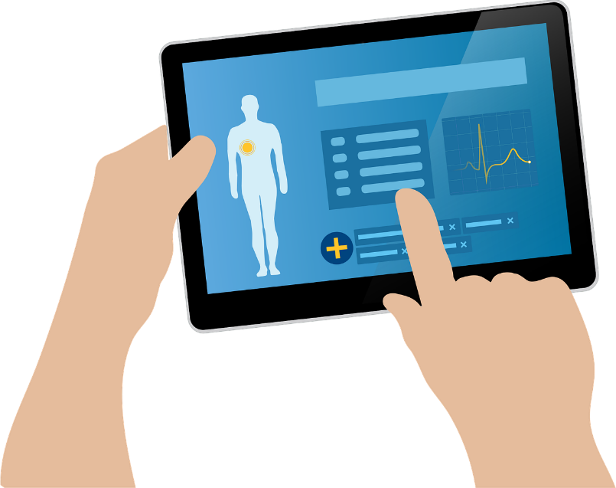
Alongside consultations, pharmacy, and diagnostics, Apollo 24/7 also emphasizes the importance of long-term health management through its Personal Health Record (PHR) feature. This digital vault consolidates a user’s medical history, including prescriptions, lab results, and uploaded reports, into one secure and accessible location. By providing visual graphs of key health parameters and allowing records to be shared seamlessly with doctors or caregivers, Apollo 24/7 transforms fragmented medical histories into a unified, lifelong health record. This not only empowers patients with greater control over their health but also enables doctors to make better, more informed decisions.
In conclusion, Apollo 24/7 has redefined how Indians access healthcare by removing barriers of time, geography, and reliability. By integrating consultations, pharmacy services, diagnostics, and premium care programs into a single digital ecosystem, it has transformed fragmented healthcare journeys into seamless experiences. Its focus on accessibility, authenticity, and affordability ensures that quality healthcare is no longer a privilege, but a service within reach for millions across the country.

Case Study: Real-World Problems and Apollo 24/7’s Innovative Solutions
Being the largest digital healthcare platform in India, Apollo 24/7 has not only revolutionized healthcare access, but also brought about a major shift in how healthcare is viewed and received. It has crafted itself into a platform that millions of Indians throughout the country access and benefit from.

Problem 1: Limited and Delayed Access to Quality Doctors

Real-World Challenge: Considering the sheer size of India and the remoteness of many villages and small towns, quality access to proper healthcare in such places is a hurdle in overall populus wellbeing. As such, many times diseases go either untreated for longer durations of time leading to untreatable or difficult to treat complications that may or may not be expensive for the individual, or it is left untreated leading to worsening complications and many times, even death. If only such conditions are diagnosed by qualified doctors holding specific expertise, it can be avoided and mitigated, and most times, treated successfully. Even in cities, the day-to-day activities of individuals sometimes do not allow them to have proper time to have themselves checked up, and delay in diagnosis of diseases always result in complications.

Apollo 24/7’s solution: The online consultation feature of Apollo 24/7 offers proper mitigation this problem in a very ingenious way. India having one of the cheapest internets in the world with very good speeds, along with smartphones that are now accessible to almost every demographic, can take complete use of this feature consulting with doctors who can diagnose the issue early and offer treatment that can either halt or even reverse the effect of the disease. The more digitally and medically literate demographic can reap even more benefits as they hold more knowledge about diseases and can help the doctors help them better by being clear, concise and specific about their issues, all while being in the comfort of their homes and without having to compromise on their daily routines and/or work. For conditions that do require in-person visits to the doctor, the platform offers the facility to book in-person appointments in the future which leaves ample room to have the visit fit into their busy schedule. This feature directly reduces delays in diagnosis, lowers avoidable complications, and saves lives.
Problem 2: Lack of Reliable and Timely Access to Medicines

Real-World Challenge: In many parts of India, patients struggle to find prescribed medicines consistently. Local chemists may have limited stock, may substitute drugs with generics of uncertain quality, or in some cases, dispense counterfeit products. Even in urban centres, last-minute rushes to pharmacies or long waits for refills cause treatment interruptions. For chronic patients (like diabetics, hypertensives), missed doses directly worsen health outcomes, increase hospitalizations, and raise overall costs.
Apollo 24/7’s solution: Through its online pharmacy feature, Apollo 24/7 guarantees quality-verified medications sourced directly from Apollo’s own pharmacy network. Medications (and healthcare essentials like supplements, devices, and Ayurvedic products) can be delivered within 2 hours in 10,000+ pin codes or scheduled for pickup from the nearest Apollo pharmacy. This system minimizes stock-outs, ensures authenticity, and reduces the patient’s dependence on local supply uncertainty. Chronic patients benefit the most. Through subscriptions, refill reminders, and doorstep delivery keep treatment continuous and hassle-free. Apollo 24/7 transforms medication access from an unpredictable chore into a reliable, fast, and safe service. By ensuring continuity of treatment and guaranteeing drug authenticity, the platform significantly improves adherence, reduces complications, and increases trust in digital healthcare delivery.
Problem 3: Inconvenient and Fragmented Access to Diagnostic Tests
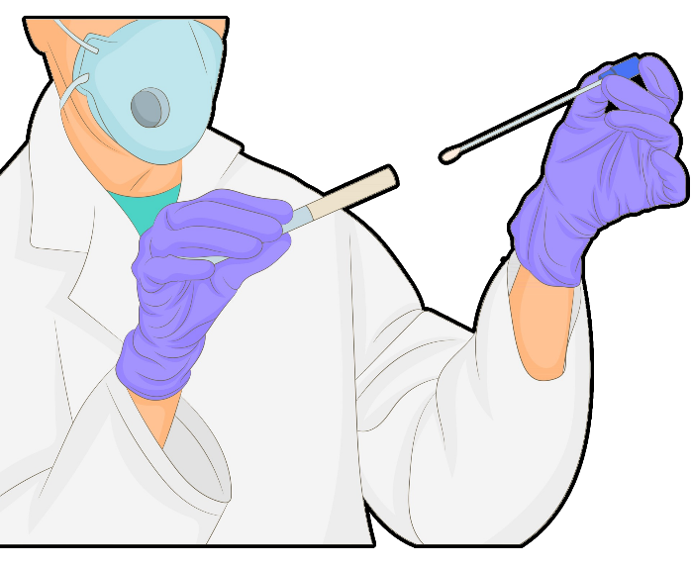
Real-World Challenge: For millions of patients, diagnostic testing means standing in long queues at hospitals or labs, arranging transportation, and often taking time off work. Reports are frequently delayed or require physical collection, making follow-ups slower and less effective. In many semi-urban or rural regions, access to certified labs is limited, leading to reliance on unverified local centres, which compromises accuracy. This lack of convenience and reliability often results in patients delaying or skipping tests altogether, directly affecting the quality of care and early detection of diseases.
Apollo 24/7’s Solution: Apollo 24/7 enables users to book diagnostic tests from home, with trained professionals collecting samples at the patient’s doorstep. Many tests offer same-day reports, delivered digitally through the app, which can also be shared directly with doctors for faster decision-making. For specialized tests that require hospital facilities, appointments can still be booked online, reducing the burden of multiple hospital visits. By integrating reports into its digital health vault (PHR), Apollo ensures patients have lifelong access to their results, eliminating the problem of misplaced lab slips or scattered health records. Apollo 24/7 simplifies the diagnostic journey by bringing accredited labs to patients’ homes and digitizing the entire process from booking to results. This not only saves time and effort but also encourages more people to undergo timely testing, leading to earlier detection, better treatment decisions, and improved overall health outcomes.
Problem 4: Scattered and Inaccessible Medical Records

Real-World Challenge: Patients in India often juggle multiple paper prescriptions, lab slips, hospital discharge summaries, and imaging reports. These records are easily lost, damaged, or forgotten during follow-ups, which disrupts continuity of care. Doctors often see patients without access to their full medical history, leading to repeated tests, misinformed decisions, or delayed diagnoses. For chronic conditions that require long-term tracking (like diabetes, hypertension, or cancer), the absence of a unified medical history is a major barrier to effective management.
Apollo 24/7’s solution: Apollo 24/7 provides a digital health vault (PHR) where users can upload, store, and organize all their medical documents. Reports from consultations, lab tests, and e-prescriptions generated within the platform are automatically added to the user’s PHR. Health parameters such as blood sugar, blood pressure, or cholesterol can be graphed over time, making trends visible to both patients and doctors. Access controls and consent features allow records to be securely shared with doctors or caregivers when needed. By centralizing health records into a single digital vault, Apollo 24/7 ensures that critical medical history is always accessible, secure, and easy to interpret. This reduces duplication of tests, improves diagnosis accuracy, and empowers patients to take an active role in managing their health.
Conclusion:
Apollo 24/7 has successfully reimagined the healthcare journey by addressing the most pressing challenges faced by patients in India. From bridging the gap in access to quality doctors through instant online consultations, to ensuring timely and authentic delivery of medicines via its online pharmacy, the platform tackles barriers that once made care fragmented and unreliable. By simplifying diagnostic testing with home collections and digital reports, and by consolidating medical histories into a secure Personal Health Record, Apollo 24/7 brings together every essential element of care into a seamless digital ecosystem. In doing so, it not only reduces delays and improves treatment outcomes, but also empowers individuals to manage their health with confidence, convenience, and continuity.

Top Features of Apollo 24/7
- Online Doctor Consultations: The platform allows patients to connect with certified doctors across more than a hundred specialties through video, audio, or chat. Users can upload medical history beforehand, ensuring better diagnosis and continuity of care.
- Online Pharmacy: Apollo 24/7 offers genuine medicines and healthcare essentials with doorstep delivery across thousands of pin codes. With a strong focus on quality assurance and speed, it ensures treatment is never delayed due to local unavailability.
- Diagnostics: Users can book diagnostic tests from home, with trained professionals collecting samples and many reports delivered the same day. Results are provided digitally, eliminating repeated hospital visits and encouraging timely testing.
- Personal Health Record (PHR): The platform provides a secure digital vault where all prescriptions, lab results, and medical reports are stored. Health parameters can be visualized as trends, making long-term management easier for both patients and doctors.
- CIRCLE Membership: Apollo 24/7 offers a premium membership program that provides priority access to doctors, exclusive discounts, and personalized wellness benefits. It enhances the user experience by rewarding loyalty and promoting holistic care.


Schema Description:
The schema for Apollo 24/7 involves multiple entities that represent different aspects of the platform. These entities include Accounts, Patients (UHIDs), Doctors, Consultations, Prescriptions, Orders, Diagnostic Tests, and Personal Health Records. Each entity has specific attributes that describe its properties and relationships with other entities, capturing the platform’s healthcare ecosystem.

Account Entity (login owner):
Accounts are the primary logins for billing, communication, and managing one or more patients (UHIDs).
- AccountID (Primary Key): Internal identifier for the account.
- Name: Account holder’s full name.
- Email: Address for account communication.
- Phone: Registered mobile number for OTP/notifications.
- Registration_Date: When the account was created.
- Default_Address: Primary delivery/contact address.
- Status: Active / Suspended / Deleted.

Patient Entity (UHID):
Each patient is uniquely identified by a UHID. One Account can manage multiple UHIDs.
- UHID (Primary Key): Unique patient identifier used across care.
- AccountID (Foreign Key referencing Account Entity): The account that manages this UHID.
- Full_Name: Patient’s name.
- Date_of_Birth: Patient’s DOB.
- Gender: Patient’s gender.
- Blood_Group (optional): Patient’s blood group.
- Allergies (optional): Known allergies.
- Chronic_Conditions (optional): Ongoing conditions (e.g., diabetes).
- Created_Date: When this UHID was added/linked to the account.

Doctor Entity:
Doctors are providers on the platform with professional identifiers.
- DoctorID (Primary Key): Unique identifier for each doctor.
- Name: Doctor’s full name.
- Specialty: Medical specialty practiced.
- Experience: Years in practice.
- Rating: Average patient rating.
- Registration_No: Official medical registration number.
- Doctor_Code (optional, unique): Internal provider code used operationally.

Consultation Entity:
Consultations record patient–doctor interactions (video, audio, or chat). Each consultation belongs to exactly one UHID.
- ConsultID (Primary Key): Unique identifier for each consultation.
- UHID (Foreign Key referencing Patient Entity): The patient for this consult.
- DoctorID (Foreign Key referencing Doctor Entity): The consulting doctor.
- Mode: Video / Audio / Chat.
- Start_Time: When the consultation begins.
- End_Time: When the consultation ends.
- Status: Scheduled / Completed / Cancelled.
- Contact_Phone_At_Booking (optional): Phone used for the call/message.

Prescription Entity:
Prescriptions are issued by doctors after consultations. Each prescription belongs to exactly one UHID.
- PrescriptionID (Primary Key): Unique identifier for each prescription.
- ConsultID (Foreign Key referencing Consultation Entity): Consultation that generated this prescription.
- UHID (Foreign Key referencing Patient Entity): Patient for whom the prescription is issued.
- Date: Date of issue.
- Notes: Additional instructions from the doctor.

Order Entity (Medicines & essentials):
Orders capture purchases from the online pharmacy. Each order is placed by an Account and is for exactly one UHID.
- OrderID (Primary Key): Unique identifier for each order.
- AccountID (Foreign Key referencing Account Entity): The account that placed the order.
- UHID (Foreign Key referencing Patient Entity): The patient the order is intended for.
- Date: When the order was placed.
- Total_Amount: Total cost of the order.
- Delivery_Status: Pending / Shipped / Delivered.
- Delivery_Address: Address where the order is delivered.

DiagnosticTest Entity:
Diagnostic tests booked through the platform. Each test booking belongs to exactly one UHID.
- TestID (Primary Key): Unique identifier for each test booking.
- UHID (Foreign Key referencing Patient Entity): The patient who booked the test.
- Test_Name: Name of the diagnostic test.
- Date: Scheduled date/time for sample collection.
- Status: Scheduled / In_Progress / Completed.
- Report_URL: Link to the digital report.

PersonalHealthRecord (PHR) Entity:
PHR is the digital vault of medical history. Each record belongs to exactly one UHID.
- RecordID (Primary Key): Unique identifier for each health record entry.
- UHID (Foreign Key referencing Patient Entity): The patient to whom the record belongs.
- Record_Type: Consultation / Prescription / Lab_Report / Other.
- File_URL: Storage location of the document.
- Created_Date: When the record was uploaded or generated.

Relationships are:
- Accounts manage Patients (UHIDs) – Each account can manage multiple UHIDs; each UHID is managed by exactly one account.
- UHIDs book Consultations with Doctors – Each UHID can have many consultations; each consultation links to exactly one UHID and one doctor.
- Consultations generate Prescriptions – A consultation can result in zero or more prescriptions; each prescription belongs to exactly one consultation (and thus one UHID).
- Accounts place Orders for a UHID – Each account can place many orders; each order is placed by one account and is for exactly one UHID.
- UHIDs book Diagnostic Tests – Each UHID can have many diagnostic tests; each test booking belongs to exactly one UHID.
- PHR stores Records for a UHID – Each UHID can have many PHR records; each PHR record belongs to exactly one UHID.
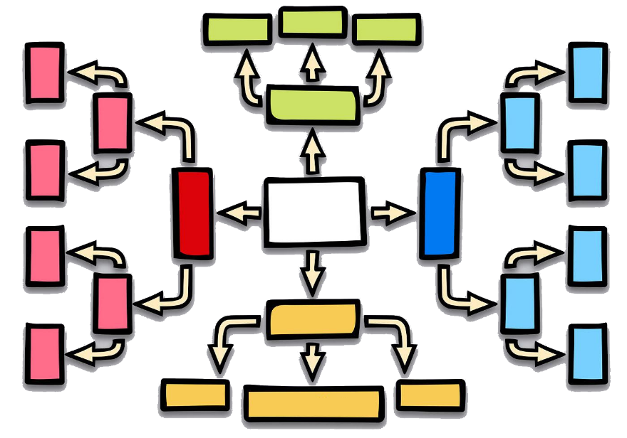
- Doctors conduct Consultations – Each doctor can conduct many consultations; each consultation is with exactly one doctor.

ER Diagram:
Here is an ER diagram that vividly portrays the relationships and attributes of the entities within the Apollo 24/7 schema. This ER diagram will serve as a visual representation, shedding light on the pivotal components of Apollo 24/7's data model. By employing this diagram, one can gain a clearer grasp of the intricate interactions and connections that define the platform's dynamics.
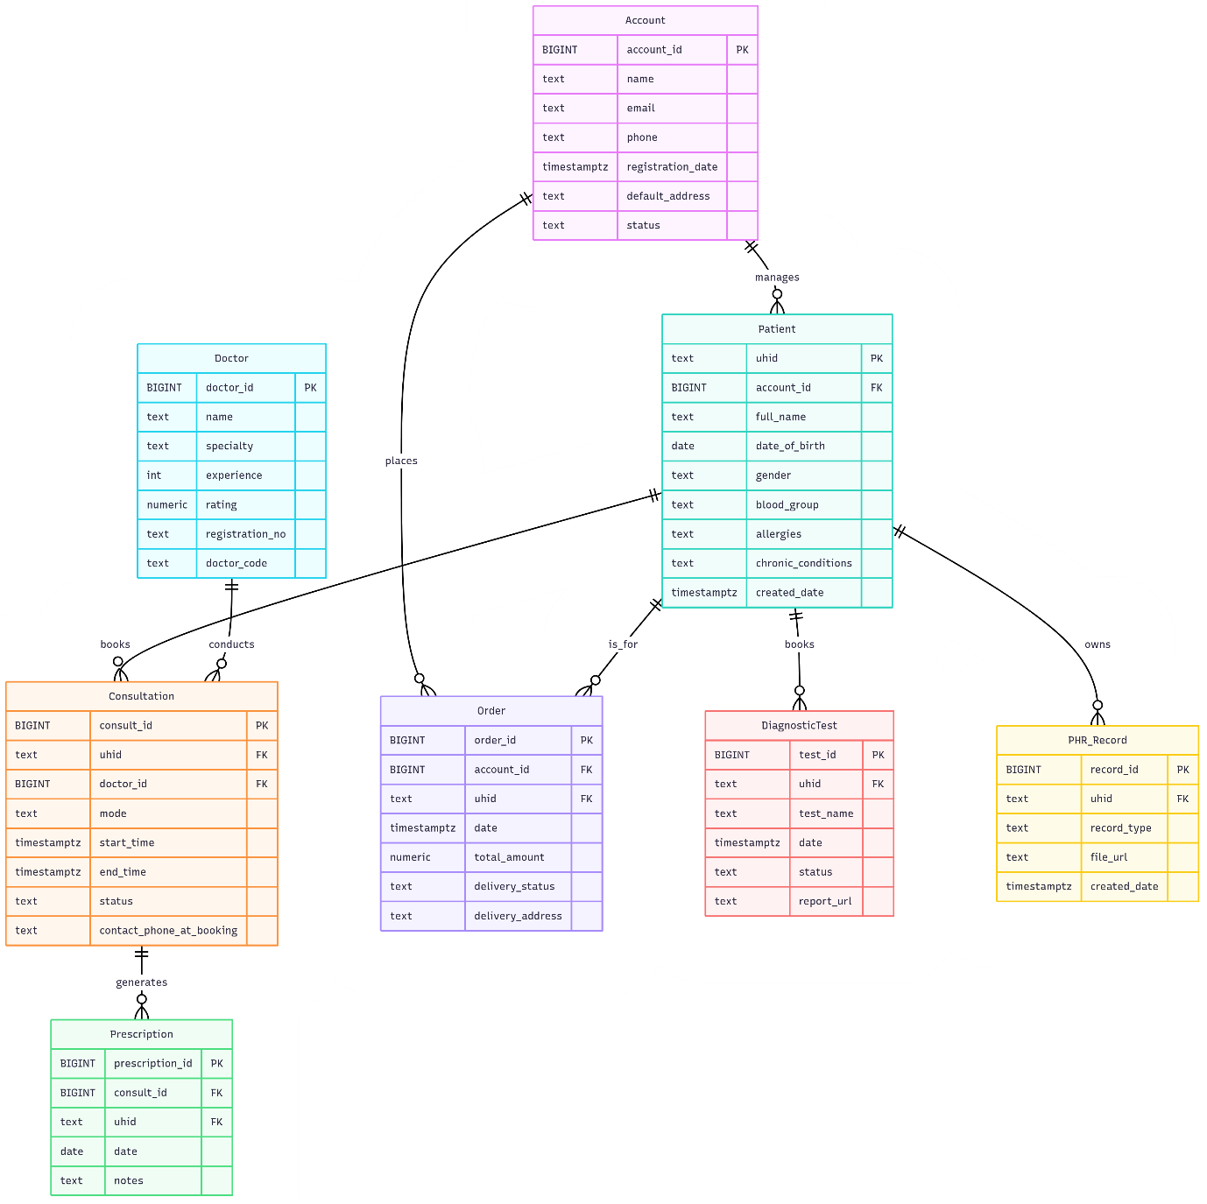
Conclusion
In this case study, the design of Apollo 24/7’s schema and Entity-Relationship diagram was studied to show how the platform delivers digital healthcare. The schema, with entities such as accounts, patients (UHIDs), doctors, consultations, prescriptions, orders, tests, and records, was found to form the foundation of its ecosystem. Through this structure, care and services are effectively managed, confirming Apollo 24/7’s role as India’s leading digital healthcare platform.

